The game collects data to evaluate the player’s performance. The scoring system (shown in the figure below) emphasizes on the two variables Si and Ci. Si is the score percentage of the note, which is determined by whether or not the player has performed the correct gesture and has the correct positioning of the ball. Ci is the total combo before the current note, which would get reset to 0 if the player fails either the gesture or the position requirement.

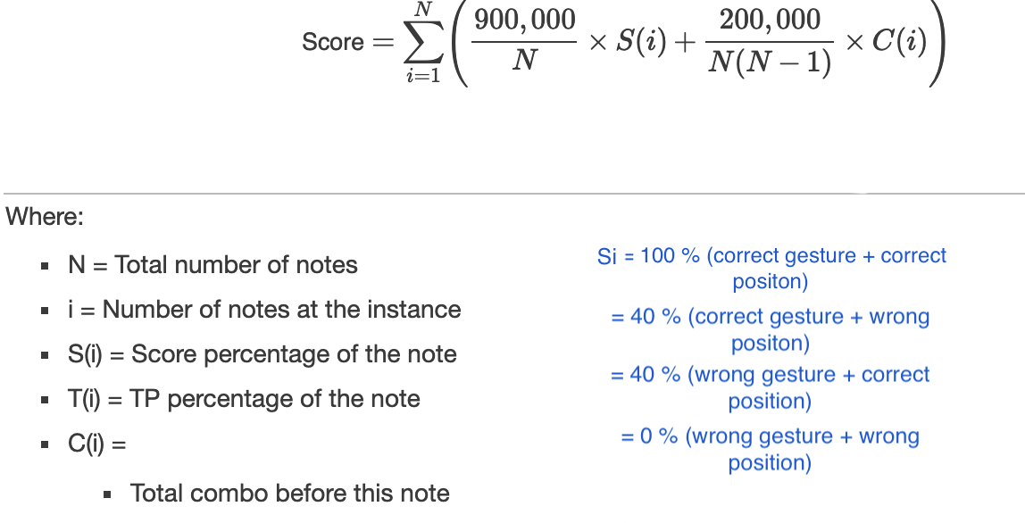

Figure 1. Scoring system.

The game also counts the number of times the player is in the wrong gesture mode, the number of times the player fails to correctly position the ball, as well as the number of times the player fails to switch gesture mode (i.e. how many times the player performs a slow gesture). Even though the player’s scores are not directly affected by these variables, the game does give the player advice at the end of the game based on these number.

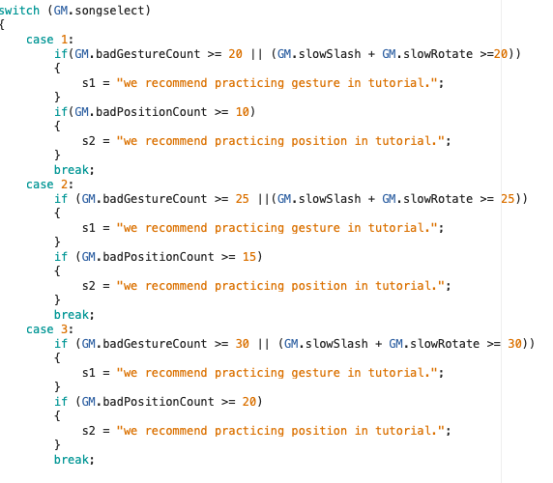

Figure 2. Feedback messages at the end of a level.